RE-ORG

1. Collections in storage are at risk
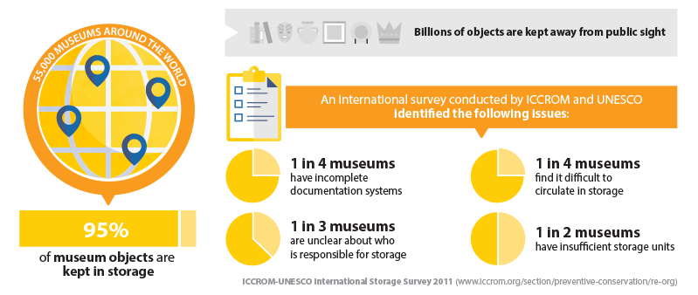

2. RE-ORG is the answer
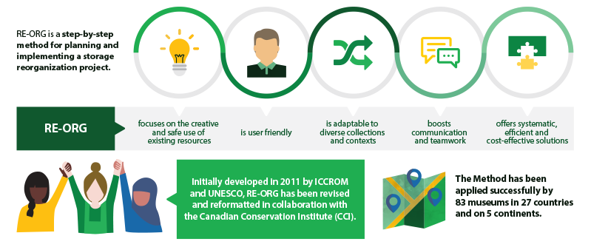

3. How does RE-ORG work ?
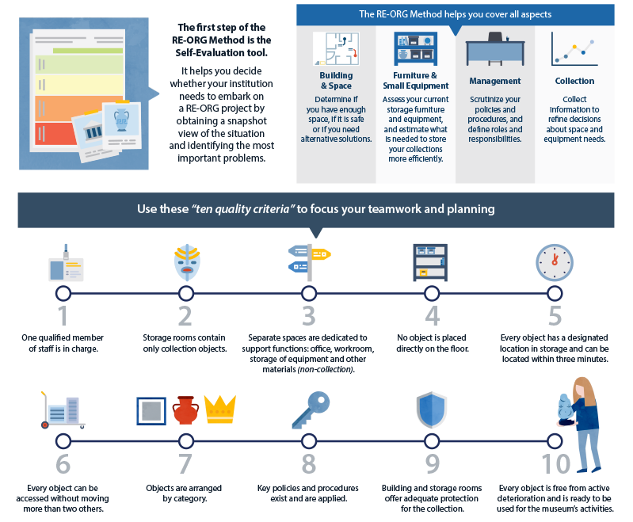

RE-ORG plakat https://www.iccrom.org/section/preventive-conservation/re-org

